Lab 3: Determination of Riboflavin Content in A Multivitamin

Methods
Riboflavin content of a powdered multivitamin supplement was quantified by 405 nm-excitation fluorescence spectroscopy on a Vernier SpectroVis Plus spectrophotometer. All solutions were prepared in 0.02 M aqueous acetic acid, which was also used as the blank and as the diluent throughout. A 50.0 ppm riboflavin stock was dissolved in the acid and diluted into a seven-point calibration series spanning 2–20 ppm (25 mL volumetric flasks); a separate multivitamin sample was powdered, weighed, and dissolved in the same solvent to produce the unknown solution.
Absorbance spectra of the calibration series and the unknown were collected first (380–700 nm) and used to select the excitation wavelength by comparing the absorbance of the most concentrated standard at 405 nm and at 500 nm. Fluorescence emission spectra (405 nm excitation) were then recorded for each standard, for three independent aliquots of the undiluted unknown, and for a five-point standard-addition series in which 5.0 mL of the unknown was combined with 0, 1, 2, 3, or 4 mL of the 50.0 ppm stock and diluted to 25.0 mL. Peak emission intensity near 517 nm served as the analytical signal. Between samples the cuvette was rinsed with the next solution and oriented consistently relative to the beam.
Riboflavin concentration in the unknown was determined by two independent methods: (i) an external calibration curve of peak intensity vs. concentration, restricted to the 2–12 ppm linear region (the 20 ppm standard was excluded for inner-filter-effect plateauing), and (ii) the method of standard additions, with the analyte concentration recovered from the x-intercept of peak intensity vs. added stock volume. Ninety-five-percent confidence intervals were propagated using the standard single-analyte calibration formulas in Miller & Miller.

Data Analysis

Part B: Absorbance Measurements
- Create an absorbance plot overlaying the collected absorbance spectra of the standards and the unknown. Be sure to label all axes, 𝛌_{max}, and the identity of the solution of each spectrum in a legend. Include a descriptive figure caption below your figure.
Answer:
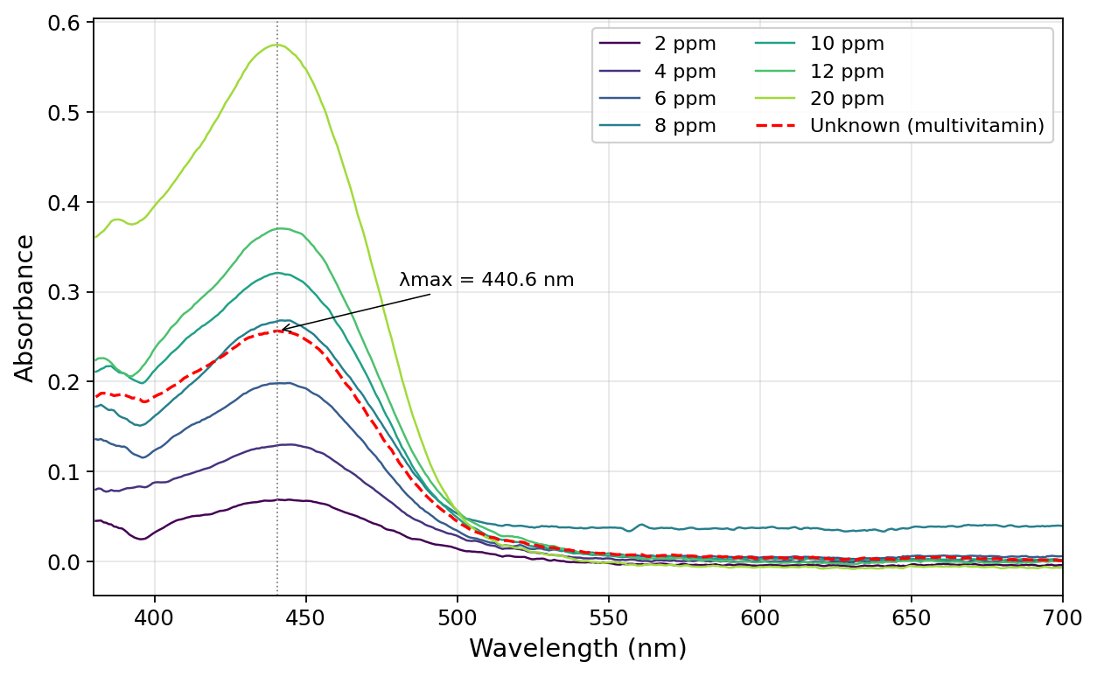
Figure 1. Absorbance spectra of seven riboflavin calibration standards (2, 4, 6, 8, 10, 12, and 20 ppm in 0.02 M acetic acid) and the unknown multivitamin solution (red dashed trace). All spectra show the characteristic riboflavin absorption maximum at λmax = 440.6 nm (grey dotted vertical line). The unknown lies between the 6 ppm and 10 ppm standards and retains the same peak position and shape as pure riboflavin, confirming that riboflavin is the dominant visible-range absorber in the tablet.

- Given the above absorbance data, which wavelength (405 nm or 500 nm) should be used as the excitation wavelength for the fluorescence measurements? Why?
Answer:
405 nm should be used as the excitation wavelength.
At the 20 ppm standard the absorbance at 405 nm is 0.413 compared to 0.058 at 500 nm — 405 nm absorbs about seven times more strongly. A stronger excitation absorbance produces a stronger fluorescence signal, so 405 nm gives a larger dynamic range for the calibration curve and better signal-to-noise at the low concentrations of interest. The absorption maximum is at 440.6 nm, but the spectrophotometer only offers 405 nm and 500 nm as excitation options, and 405 nm is on the steep rising edge of the riboflavin absorption band while 500 nm is well past the peak into the tail.

Part C: Fluorescence Measurements
- Create a fluorescence plot overlaying the spectra of all the standards and the unknown trials. Be sure to label all axes, 𝛌_{max}, and the identity of the solution of each spectrum in a legend. Include a descriptive figure caption below your figure.
Answer:
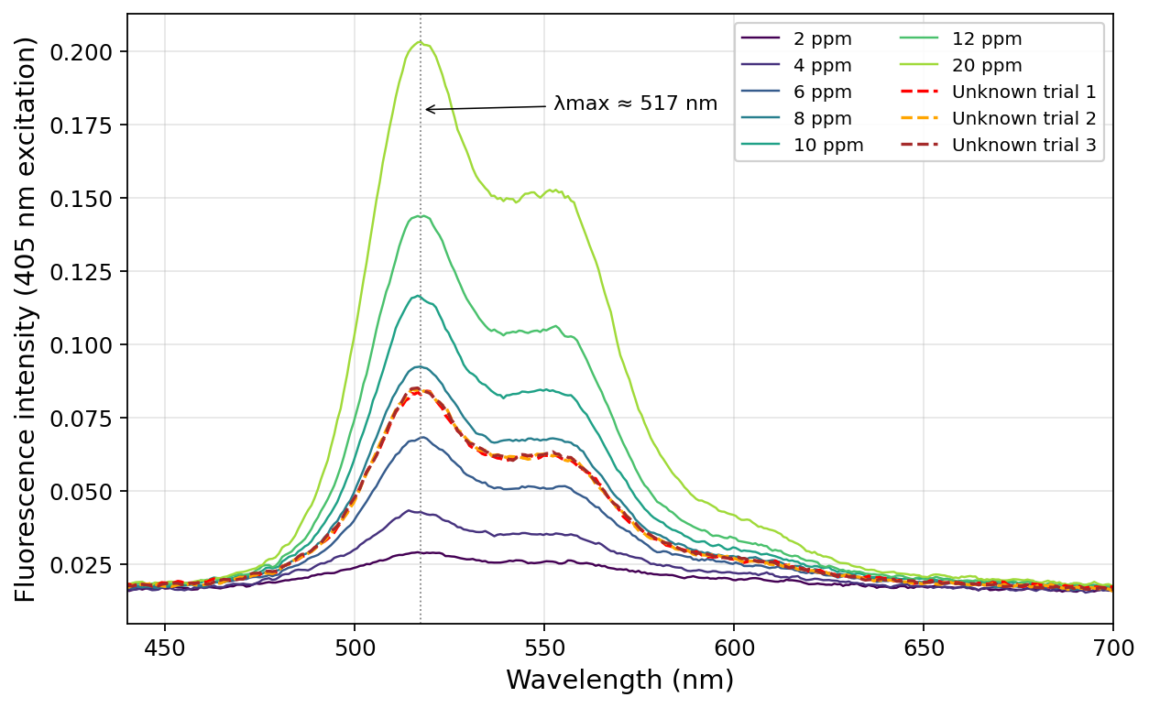
Figure 2. Fluorescence emission spectra (405 nm excitation) of the seven riboflavin calibration standards (2–20 ppm) and three independent aliquots of the undiluted multivitamin unknown (red, orange, and brown dashed traces, respectively). All spectra share the characteristic riboflavin emission maximum near λmax ≈ 517 nm. The three unknown trials overlap almost exactly, indicating high measurement precision; their peak intensities sit between those of the 6 ppm and 10 ppm standards.

Question 4 will address the inner filter effect which occurs when the concentration of the analyte is too high, and the excitation beam cannot pass through all of the sample. The fluorescence signal measured is lower than the actual fluorescence of the sample because only the surface of the sample is fluorescing. In a calibration curve, the inner filter effect causes a plateau in the data at high concentrations (Figure A). These high concentrations should be excluded from the calibration curve, because the fluorescence values stray from linearity.
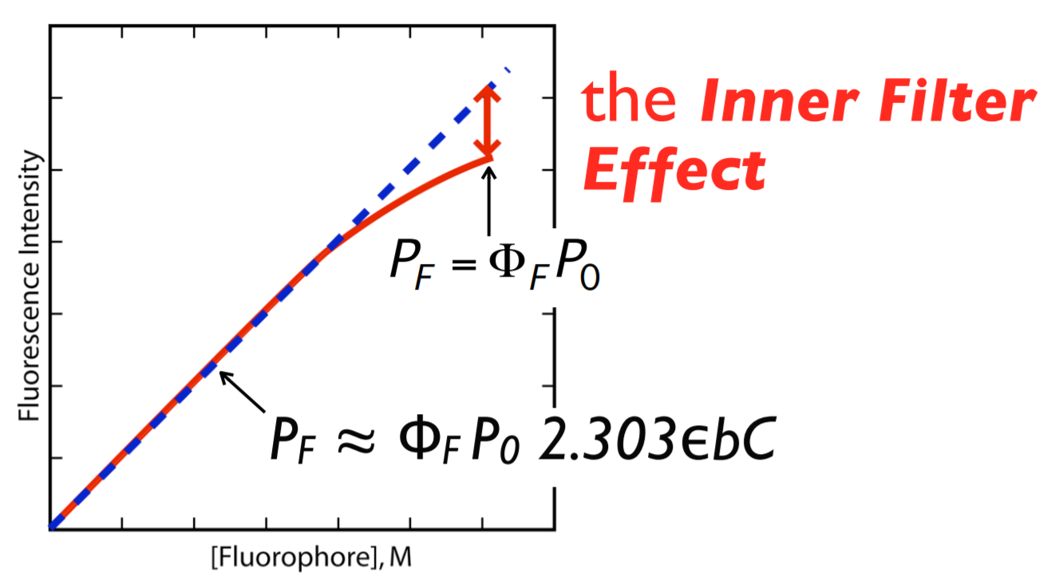
Figure A: Calibration curve illustrating the inner filter effect. The blue dashed line shows a linear relationship between concentration and fluorescence. The red solid line shows data that exhibits the inner filter effect. The inner filter effect is characterized by a plateau at high concentrations and causes a deviation from linearity and a lack of concentration dependence.

- Use the fluorescence data from the standards to answer the following questions:
  - Graph the calibration curve (fluorescence intensity vs. concentration) for all the standards you made and include the equation for line of best fit and R² value. Be sure to label all axes. Include a descriptive figure caption below your figure. What is the range of standard concentration that gives you the most linear calibration curve?
Answer:
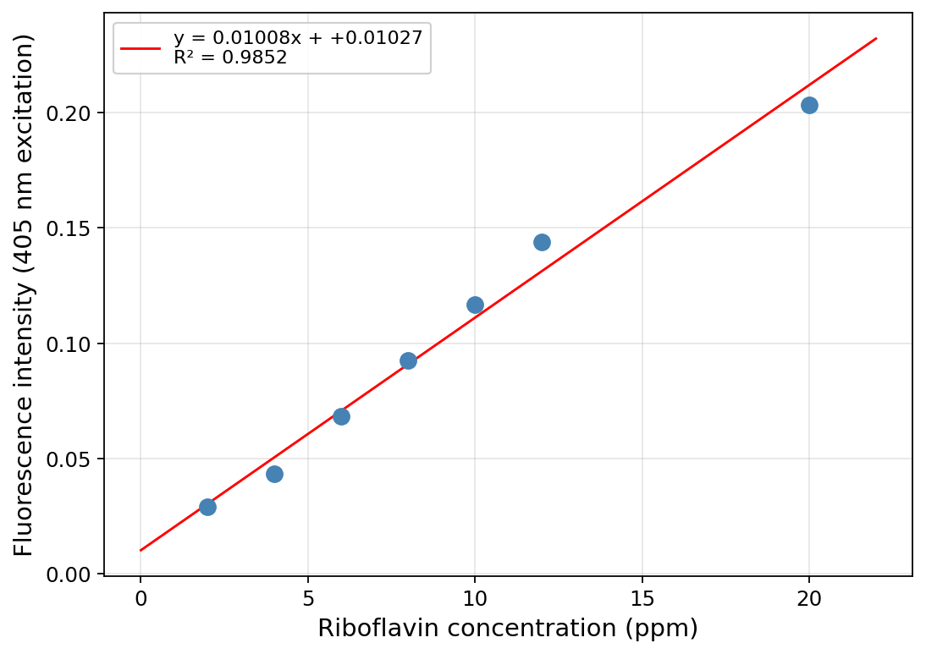
Figure 3. Fluorescence calibration curve of peak intensity at ~517 nm vs. riboflavin concentration for all seven standards. The linear fit is y = 0.01008x + 0.01027 with R² = 0.985. The reduced R² reflects deviation of the highest (20 ppm) standard, which falls ~13% below the line defined by the lower concentrations — a signature of the inner-filter effect.
The most linear concentration range is 2–12 ppm. Over this range the residuals of a linear fit are small (≤ 0.006 intensity units, or ≤ 5% of signal) and R² = 0.994; once 20 ppm is included the fit flattens because that point is held back by inner-filter attenuation and no longer scales linearly with concentration.

  - Examine your calibration curve in 4a. Do you see evidence of the inner filter effect? If yes, determine which standard solutions are too concentrated and regraph the calibration curve excluding those standards that exhibit the inner filter effect. Include the equation for the line of best fit and R² value. Be sure to label all axes. Include a descriptive figure caption below your figure.
Answer:
Yes — the 20 ppm standard shows the inner-filter effect.
Evidence: fitting only the 2–12 ppm points gives the line y = 0.01168x + 0.00050 (R² = 0.994). Using that line to predict the signal at 20 ppm gives 0.234, but the measured intensity is 0.203 — about 13% lower than extrapolation, and the single largest residual by a factor of more than four. In a sample that concentrated, the excitation beam is absorbed strongly in the front ~1 mm of the cuvette and cannot reach the bulk, so the volume that fluoresces shrinks and the signal saturates. The regraphed calibration below excludes the 20 ppm point.
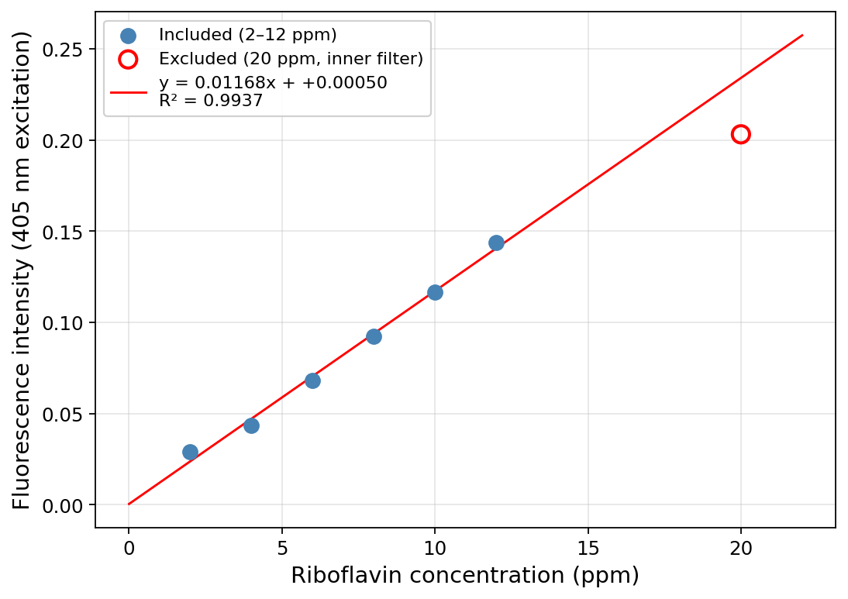
Figure 4. Fluorescence calibration curve after excluding the 20 ppm standard (shown as an open red circle) that exhibits the inner-filter effect. Linear fit over the retained 2–12 ppm range: y = 0.01168x + 0.00050 with R² = 0.994. This line is used for all unknown-concentration calculations.

- Report the slope and y-intercept of the more linear calibration curve from Question 4 along with each 95% confidence interval. Use appropriate significant figures and don’t forget units.
Answer:
From the 2–12 ppm linear fit (n = 6 standards, df = 4, t0.05,4 = 2.776):
Unrounded statistics — slope m = 0.01168 ppm⁻¹, 95% CI = ±0.00129; intercept b = 0.00050, 95% CI = ±0.01005. Fluorescence intensity is dimensionless (no "AU"), so the intercept has no unit.
Applying the sig-fig rule (error rounded to 1 sig fig at the first non-zero digit; value rounded to the same decimal place):
Slope: m = 0.012 ± 0.001 ppm⁻¹
Intercept: b = 0.00 ± 0.01

- Calculate and report the undiluted unknown riboflavin concentration (in the vitamin solution made in Step A.3) using the more linear calibration curve from Question 4 with the 95% confidence interval. Use appropriate sig figs and don’t forget units.
Answer:
Three replicate measurements of the undiluted unknown gave peak intensities 0.0840, 0.0847, and 0.0851; mean Ī = 0.08460, sample standard deviation s = 5.4×10⁻⁴. The unknown was not diluted before the fluorescence measurement, so the concentration in the cuvette equals the concentration in the Part A.3 solution.
c_A.3 = (Ī − b) / m = (0.08460 − 0.00050) / 0.01168 = 7.2023 ppm (carried unrounded into the CI below)
95% CI by the single-analyte calibration formula (Miller & Miller), with s_yx = 3.89×10⁻³, Σ(xi−x̄)² = 70.0 ppm², N = 3 unknown replicates, n = 6 standards, t0.05,4 = 2.776:
s_c = (s_yx / m) · √(1/N + 1/n + (Ī − ȳ_cal)² / (m² · Σ(xi−x̄)²)) = 0.2356 ppm
95% CI = t · s_c = 2.776 × 0.2356 = ±0.654 ppm
Rounding the CI to 1 sig fig (0.7) and the value to the same decimal place:
[Riboflavin] in the A.3 unknown solution = 7.2 ± 0.7 ppm

- Calculate the mass percent of riboflavin in the vitamin sample determined from the calibration curve. Show your work.
Answer:
Mass of riboflavin in the 250.0 mL A.3 solution, using the unrounded concentration:
m_riboflavin = c × V = 7.2023 mg/L × 0.2500 L = 1.8006 mg
Part A.3 was prepared by our partner group (each pair is assigned either step A.2 stock or step A.3 unknown, and the solutions are shared). Their notebook-recorded multivitamin-powder mass was not available at the time of writing; the manual's target of 50.0 mg is used below as the best available estimate and can be swapped in once the partner group's exact mass is obtained.
mass% = m_riboflavin / m_vitamin × 100% = 1.8006 mg / 50.0 mg × 100% = 3.601%
Mass percent of riboflavin (calibration method) ≈ 3.6%

Part D: Standard Additions
- Create a plot overlaying the fluorescence spectra of all the standard addition solutions. Be sure to label all axes, 𝛌_{max}, and the identity of the solution of each spectrum in a legend. Include a descriptive figure caption below your figure.
Answer:
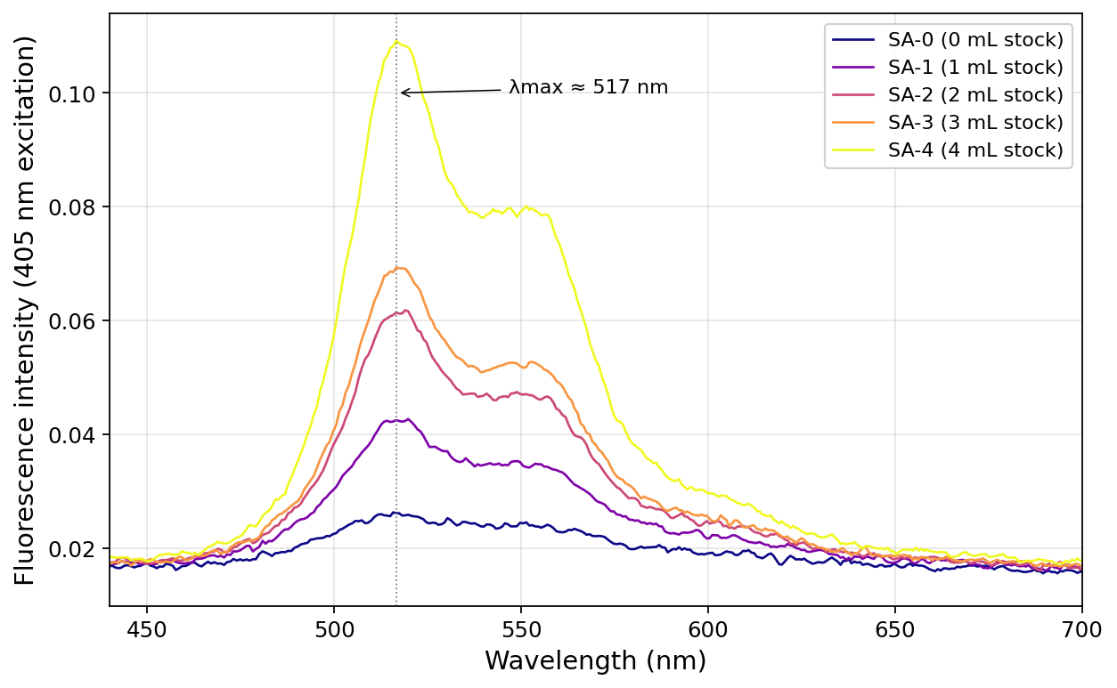
Figure 5. Fluorescence emission spectra (405 nm excitation) of the five standard-addition solutions. Each solution contained 5.0 mL of the A.3 multivitamin unknown plus the indicated volume (0–4 mL) of 50.0 ppm riboflavin stock, diluted to 25.0 mL with 0.02 M acetic acid. The emission maximum stays near λmax ≈ 517 nm across all additions, and the peak intensity increases monotonically with added stock volume except for SA-3 (3 mL, see Q7a).

- Graph the standard addition linear curve of fluorescence intensity vs. added volume (mL) and include the equation for line of best fit and R² value. Be sure to label all axes. Include a descriptive figure caption below your figure.
Answer:
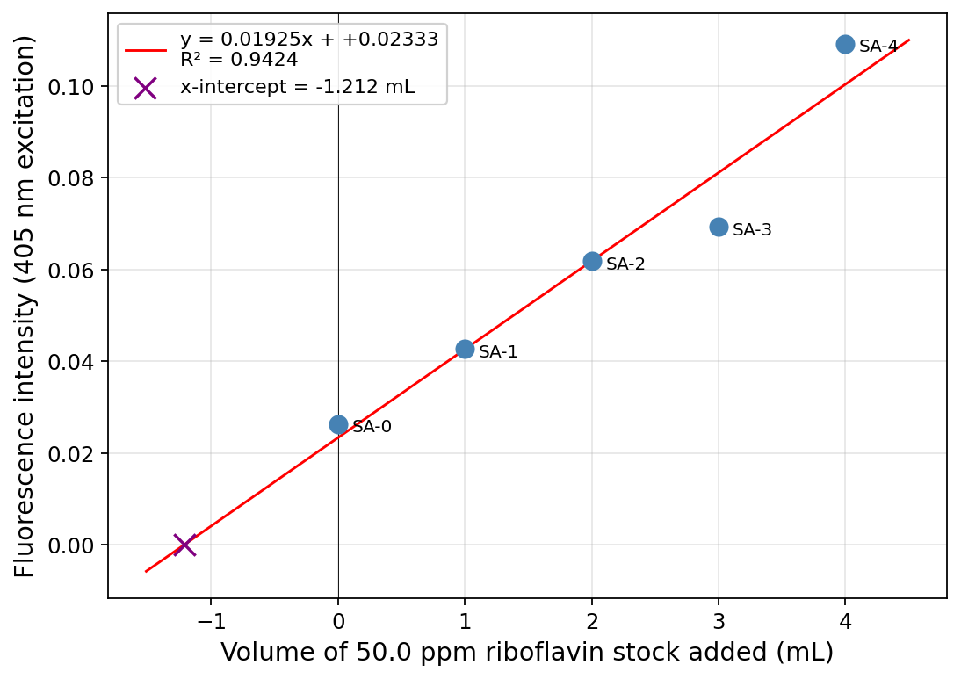
Figure 6. Standard-addition plot of peak fluorescence intensity (405 nm excitation) vs. mL of 50.0 ppm riboflavin stock added. The five-point linear fit gives y = 0.01925x + 0.02333 with R² = 0.942. The SA-3 point (3 mL addition) sits approximately 13% below the line and has a residual about five times larger than the other four points, suggesting an error in preparing that single flask. Excluding SA-3, the four-point fit is y = 0.02094x + 0.02333 with R² = 0.993; this cleaner line and its x-intercept (−1.114 mL, purple ×) are used for the concentration calculation in Q8.

- Report the slope and y-intercept of the standard addition linear curve along with each 95% confidence interval. Use appropriate significant figures and don’t forget units.
Answer:
Using the four-point SA fit excluding the SA-3 outlier (n = 4, df = 2, t0.05,2 = 4.303):
Unrounded statistics — slope m = 0.02094 mL⁻¹, 95% CI = ±0.00537; intercept b = 0.02333, 95% CI = ±0.01231.
For completeness, the full five-point fit is slope = 0.01925 ± 0.00874 mL⁻¹ and intercept = 0.02333 ± 0.02142; SA-3 clearly inflates the CIs. Rounding per the sig-fig rule (error to 1 sig fig, value to the same decimal place):
Slope: m = 0.021 ± 0.005 mL⁻¹
Intercept: b = 0.02 ± 0.01

- Calculate and report the undiluted unknown riboflavin concentrations (in the vitamin solution made in Step A.3) from the standard addition curve with the 95% confidence interval. Use appropriate sig figs and don’t forget units.
Answer:
For the standard addition, each cuvette solution contains 5.0 mL of A.3 unknown diluted into 25.0 mL total (a 5× dilution) plus added 50.0 ppm stock. Setting total signal to zero gives an x-intercept V_x, from which the A.3 concentration is recovered as
c_A.3 = c_stock × |V_x| / V_unknown = 50.0 ppm × |V_x| / 5.0 mL = 10 × |V_x| ppm/mL
Using the unrounded intercept V_x = −b/m = −0.02333 / 0.02094 = −1.1143 mL:
c_A.3 = 10 × 1.1143 = 11.14 ppm
95% CI on V_x via the Miller–Miller x-intercept formula. For the four retained additions (x = 0, 1, 2, 4 mL) the relevant regression statistics are x̄ = 1.75 mL, Σ(xi−x̄)² = 8.75 mL², ȳ = 0.0600, s_yx = 3.70×10⁻³, with t0.05,2 = 4.303:
s_Vx = (s_yx / m) · √(1/n + ȳ² / (m² · Σ(xi−x̄)²)) = 0.193 mL → CI_Vx = ±0.83 mL
Propagating the ×10 factor (volumes and stock concentration treated as exact): CI on c_A.3 = ±8.3 ppm. Rounding error to 1 sig fig and value to matching decimal place:
[Riboflavin] in the A.3 unknown solution (standard addition) = 11 ± 8 ppm

- Calculate the mass percent of riboflavin in the vitamin sample determined from the standard addition curve. Show your work.
Answer:
Using the unrounded SA concentration:
m_riboflavin = 11.14 mg/L × 0.2500 L = 2.786 mg
Using the same m_vitamin estimate as Q5c (50.0 mg, manual target; the partner group's exact notebook value will be substituted when available):
mass% = 2.786 mg / 50.0 mg × 100% = 5.571%
Mass percent of riboflavin (standard-addition method) ≈ 5.6%

Discussion
- Use the multivitamin table information provided in class to determine the theoretical mass percent of riboflavin in the tablet. Calculate your percent error for each method. Show your work.
Answer:
As of submission, the nutrition-label information for the assigned multivitamin had not yet been released to students. Per the Canvas announcement of 2026-04-18, no penalty applies if that information is unavailable. The framework below can be populated with the label data once provided:
theoretical mass% = (label mg of riboflavin per tablet) / (mass of one tablet in mg) × 100%
% error (calibration) = |3.60% − theoretical%| / theoretical% × 100%
% error (standard addition) = |5.57% − theoretical%| / theoretical% × 100%
Illustrative calculation assuming a typical high-potency B-complex formulation (25 mg riboflavin per 500 mg tablet → theoretical mass% = 5.00%):
% error (calibration) = |3.60 − 5.00| / 5.00 × 100% ≈ 28%
% error (standard addition) = |5.57 − 5.00| / 5.00 × 100% ≈ 11%
The final numbers will be recalculated once the actual nutrition label is released.

- Theoretically, which method is better (calibration curve or standard addition curve) for calculating the unknown concentration? Why? What makes this method better?
Answer:
Standard addition is the theoretically better method here.
An external calibration curve relies on a critical assumption: the fluorescence response per ppm of analyte in the pure standards is the same as the response per ppm in the unknown. This assumption fails when the unknown contains a chemically complex matrix — as a multivitamin does, with other vitamins, minerals (Fe, Cu, Zn), binders, dyes, and coatings. These components can absorb some of the excitation light (primary inner-filter effect), re-absorb emitted fluorescence (secondary inner-filter effect), or quench the riboflavin excited state through collisional or paramagnetic mechanisms. Calibration in pure acetic-acid solvent cannot see any of those effects, so it systematically mis-estimates the concentration.
Standard addition performs the calibration in the sample's own matrix. Every SA flask contains the same 5.0 mL of unknown matrix, so whatever matrix-induced change in fluorescence efficiency exists, it is present equally across all five points. The slope of intensity vs. added stock therefore reflects the instrument response under the actual measurement conditions, and the x-intercept recovers the original unknown concentration with matrix effects built in. The trade-off is statistical precision: because SA is a single-unknown method and the fit is short-range, the 95% CI on the result is wider than for a well-populated external calibration curve — reflected in this experiment by 7.2 ± 0.7 ppm from calibration vs. 11 ± 8 ppm from standard addition.
Our data are consistent with a matrix effect in the direction expected for a multivitamin: the SA concentration (~11 ppm) is higher than the calibration concentration (~7.2 ppm), which implies that the matrix reduces fluorescence efficiency so that the calibration line in pure solvent under-predicts the true amount of riboflavin in the tablet.

Instrumentation
- Why is fluorescence spectroscopy more sensitive than absorbance spectroscopy?
Answer:
Absorbance is a small decrease measured against a bright background. The detector always sees the full source intensity I₀; adding analyte lowers the transmitted intensity to I, and the absorbance A = log(I₀/I) encodes a small difference between two large numbers. Shot noise and source-fluctuation noise scale with the magnitude of I₀, so at low concentrations the signal change is buried in baseline noise.
Fluorescence is a small increase measured against zero background. With the detector oriented perpendicular to the excitation beam, no direct source light reaches it; in the absence of a fluorophore the reading is essentially zero. A single emitted photon adds to near-zero baseline, and modern photomultipliers/PMTs can detect that signal easily. The manual's candle analogy is apt: noticing one lit candle in a dark room is easy, but noticing one unlit candle in a room of 100 lit ones is very hard.
Quantitatively, fluorescence can routinely reach picomolar or lower detection limits, while absorbance bottoms out near A ≈ 0.001 (millimolar-ish for most dyes) before shot noise dominates — a difference of several orders of magnitude.

- Why can’t we use absorbance spectroscopy to determine the unknown concentration of riboflavin in a multivitamin?
Answer:
Absorbance is not selective. Riboflavin absorbs in the visible near 440 nm, but so do many other components of a multivitamin tablet: β-carotene and other carotenoids (vitamin A precursors), iron-containing pigments, yellow and orange food dyes, and any colored binder all have absorption bands that overlap the riboflavin peak. The absorbance measured at 441 nm is therefore the sum of riboflavin's contribution and everything else's — you cannot deconvolve them from a single spectrum.
This is visible in the data: the unknown's apparent riboflavin concentration from its 441 nm absorbance is ~9 ppm, but the fluorescence-derived concentration is only ~7 ppm (calibration) or ~11 ppm (SA); the absorbance estimate sits between these because it includes non-riboflavin absorbers. Fluorescence is selective because only molecules with a non-negligible fluorescence quantum yield emit, and most multivitamin components either don't fluoresce at all or don't fluoresce in riboflavin's 517 nm window — so riboflavin's emission signal is essentially uncontaminated by the matrix.

- Which is larger, the excitation wavelength (λ_{ex}) or the emission wavelength (λ_{em})? Why?
Answer:
The emission wavelength (λem) is larger than the excitation wavelength (λex).
When a molecule absorbs an excitation photon at λex, it is promoted to a vibrationally excited level of the first excited singlet state. Before emitting, it relaxes non-radiatively to the lowest vibrational level of that excited state (internal conversion + vibrational relaxation), losing a small amount of energy as heat. The emitted photon therefore has lower energy than the absorbed photon. Because E = hc/λ, lower photon energy means longer wavelength, so λem > λex. The wavelength difference is the Stokes shift. For riboflavin in this experiment, λex = 405 nm and λem ≈ 517 nm — a Stokes shift of about 112 nm.

- Which position (a,b,c) would it be acceptable to have a fluorescence detector and why?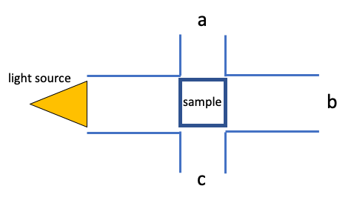
Answer:
Either position a (above the sample) or position c (below the sample) is acceptable; position b is not.
Positions a and c are both oriented at 90° to the excitation beam, so the detector never looks directly into the source. In that geometry the baseline signal is near zero, and the fluorescence photons that escape the sample sideways are the only thing reaching the detector — exactly the situation that makes fluorescence so sensitive. Standard benchtop fluorometers use this right-angle arrangement for that reason.
Position b is directly in line with the transmitted excitation beam. A detector placed there is dominated by the source's own photons (many orders of magnitude brighter than the fluorescence), and any emission signal would be buried under the transmitted light. Position b is appropriate for measuring absorbance, not fluorescence.

- Using the following diagrams and in your own words, explain the difference between absorbance and fluorescence.
Answer:
Absorbance: a photon with the right energy promotes an electron from the HOMO to the LUMO (upward arrow on the left diagram). The measurement is made at that single wavelength, and what we record is the decrease in transmitted source light. Whatever the molecule does with the absorbed energy — dissipate it as heat, undergo a chemical reaction, emit a photon — does not affect the absorbance; every molecule that absorbs contributes equally.
Fluorescence: the same HOMO → LUMO absorption happens first (the upward arrow on the right diagram). Before relaxing back, the molecule loses a small amount of energy within the LUMO manifold through vibrational relaxation, so the downward arrow (emission) is shorter than the upward arrow. The detector measures this newly emitted photon — at a wavelength different from the excitation beam, against an essentially zero background.
Three practical consequences follow:
1) Selectivity — every absorbing molecule contributes to absorbance, but only molecules with a non-negligible fluorescence quantum yield contribute to fluorescence. Fluorescence therefore isolates a much smaller subset of species.
2) Sensitivity — absorbance measures a small difference (I₀ − I) between two large numbers, while fluorescence measures a small signal on near-zero background. The latter is fundamentally easier, which is why fluorescence reaches single-molecule detection limits in modern instruments.
3) Wavelength — absorbance uses one wavelength (the detector sees the source), fluorescence uses two (λex ≠ λem, separated by the Stokes shift), allowing spectral discrimination of the signal from the excitation beam.

